Seattle Opportunities for Opening a Gym

CMP

The rise of the internet has undermined the old adage that the three rules of business are “location, location, location;” however, just as the internet undermines the advantage of location in most regions, those benefits accrue to other regions—major internet companies have yet to truly embrace dispersed workforces, and these companies must therefore locate somewhere. Likewise, for certain centers of the economy location remains extraordinarily important. Such a region that benefits from the internet’s disrupting effects is the Seattle region, home to numerous tech companies, and such a business is that of the humble gym.

Seattle has a firm footing both in the new technologically driven economy and in the older industrial economy. Amazon is headquartered in South Lake Union near a major Google office, while Microsoft is headquartered in nearby Redmond. Meanwhile, there are a fluctuating but large number of small tech companies of just a few people each. This tech economy is accompanied by a strong industrial economy—with both Boeing’s headquarters, the port, and the current boom in construction jobs. Seattle has a strong economy.

This strong performance in the industrial and tech economy creates opportunities in the service industry—and particularly when it comes to exercise. It is not so easy to deliver exercise to one’s front door (though committed joggers may disagree), and the idea of outsourcing it to another country is laughable unless one is discussing recruiting some foreign athletes to the US Olympic team (or another sport). Moreover, from a gym’s perspective there is a wonderful coincidence of a population that is simultaneously more overweight and more health-conscious than in the past. Many of us feel unhealthy and feel guilty about it—enough that it should put a smile on every gym-owner’s face. This raises the simple question of *where* one should build a gym though. Should one target Seattle’s urban core, or the periphery?

# The Data

This project looks at three sources of data. The first of these is simply geographic data of the various neighborhoods in Seattle as assembled by Zillow. Relying on approximations such as the radius from the center of a neighborhood are not very reliable when there are no circular neighborhoods in Seattle, and very few that would even approximate a square (names like Pioneer Square being misleading with respect to normal polygons).

The second data source are growth projections for housing provided by the Seattle city government. While this data does not include all districts within Seattle, it consists of what the city government has deemed the most important from a planning perspective. Working with the city’s growth plans is likely a better business plan than working against them.

The third data source is a dataset of gyms within Seattle assembled using Foursquare. Entrepreneurs looking to open a new gym could use this for one of two strategies: opening a new venue in an area where people tend to go for gyms (Downtown, Belltown or Ballard), or opening a new venue with few to no competitors.

# Methodology

This project is more about identifying the good locations to explore opening a new venue than it is about the details of property values, profit margins, and running a gym. Accordingly, it focuses more on which of Seattle’s neighborhoods are projected to grow, and where the gyms are located.

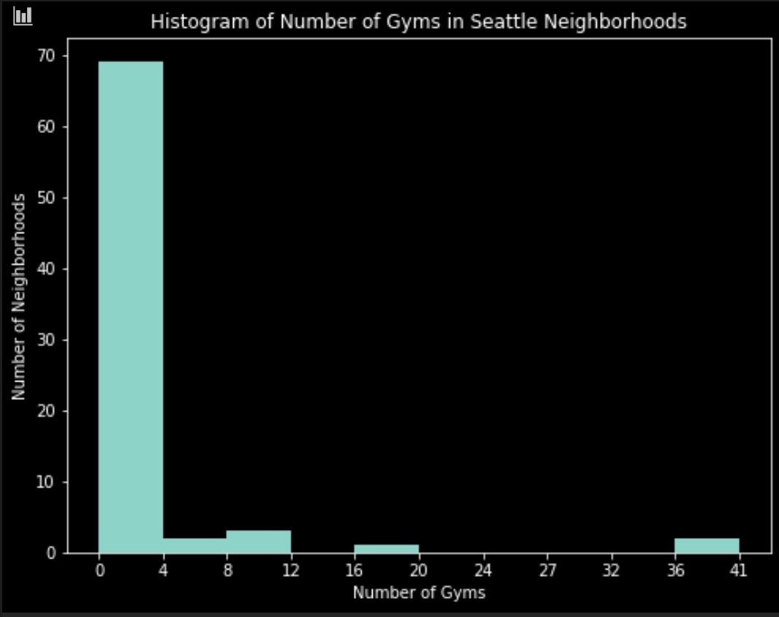

Looking at a histogram of gym counts by neighborhood, most of Seattle’s neighborhoods have few to no gyms. Even focusing on neighborhoods adjoining the downtown area, it is curious that even populous districts such as the International District and Capitol Hill have few. Moreover, some of these regions have strong growth projections in the near future—suggesting they could be good places to open a new gym.

This project also uses DBSCAN to identify different gym clusters around Seattle. The analysis found one major cluster centered on Seattle’s downtown containing the majority of gyms, and a second minor cluster in Ballard, with the remainder of gyms being essentially orphans outside of any cluster.

# Results

Our data consists of expected growth in important urban centers and villages through Seattle, gym counts for each neighborhood, and the locations of each of these venues. We are not delving into issues of financing a gym at this point (though one can safely assume that anything downtown would be more expensive to run). Therefore, we will be looking at two different visuals: a bar graph and map of the combined data.

## The Bar Graph

The bar graph shows Seattle's 2015 housing stock (divided by 100), its projected 2030 housing stock, and the number of gyms in the neighborhood. Several districts that stand out are Capitol Hill, South Lake Union, Belltown, Ballard, and unsurprisingly Downtown.

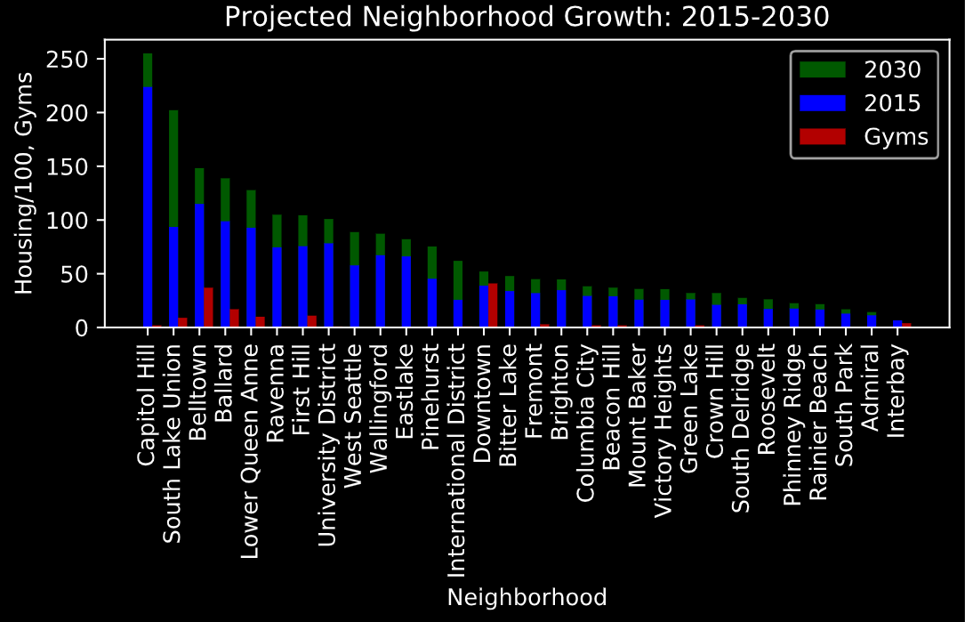

Downtown is notable for being in the middle for housing stock, but having more gyms than any other district. This is in marked contrast to Capitol Hill, which is near the bottom for gyms, but has the most housing. It is likely that many Capitol Hill residents simply go to Downtown to use the gym.

Belltown and Ballard both stand out for having plenty of housing stock as well as large numbers of gyms. Belltown adjoins Downtown, so its gyms are part of the same cluster, whereas Ballard constitutes an independent gym cluster. Both have healthy growth projections over the next decade—suggesting they would be good places to open a gym

Finally, South Lake Union stands out for having the highest projected growth of any neighborhood in Seattle. The small number of gyms relative to the projected growth suggest this would be an excellent place to open a new gym to cater to newcomers.

## The Map

This Seattle Map consists is showing two things: the projected growth of various neighborhoods in Seattle and the locations of different gyms by cluster (the red circles are for checking the name of the district). Districts with a more reddish hue are expected to have higher growth by 2030. Neighborhoods excluded from Seattle’s growth projections are instead marked in green. Gyms are marked in blue (main cluster), purple (secondary cluster), or grey (no cluster).

The map both supplements insights of the bar graph and provides some of its own. The two neighborhoods with the most gyms: Downtown and Ballard, are also both centers of gym clusters. Meanwhile, many neighborhoods have few or no gyms at all, suggesting that there are ample opportunities to open a new venue--some of which also have good growth projections. However, one important caveat is that the data Foursquare provides excludes several known gyms—including two in the University District run by the University of Washington. If opening a gym in Seattle is no more difficult than opening a brewery, there should be it should be relatively easy to get started.

# Discussion

Those looking to open a new gym have a choice between what we are dubbing the downtown gym, Ballard Gym, and neighborhood Gym strategies.

The downtown cluster is the most likely to see economies of scope. A market large enough to support over 50 gyms (when Belltown, South Lake Union and First Hill are included), can also support a number of more specialized gyms. Specialization could mean emphasizing a kind of exercise like rock climbing, or a kind of experience.

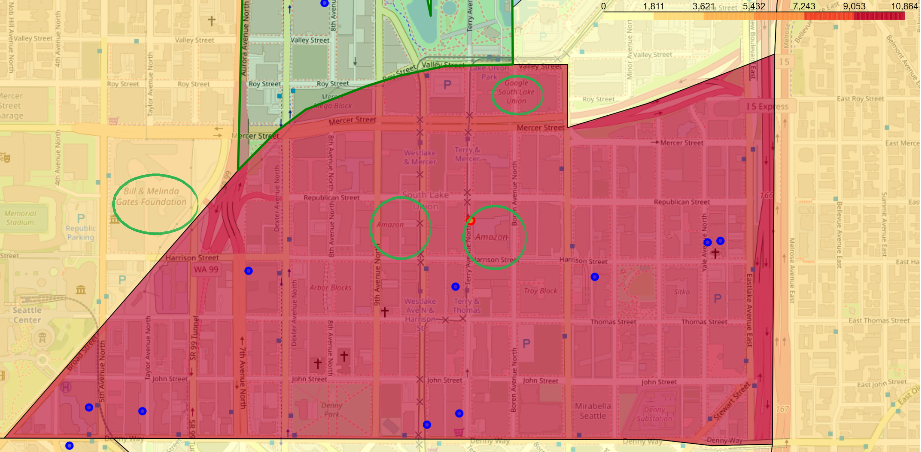 Many downtown gyms also seem instead to compete by securing a captive cliental. This includes hotel and apartment gyms, which may be subsidized by their residents. There even seem to be gyms connected to office buildings, such as the Russell Investments Building Gym. Even without such a connection, gyms may simply try to locate near a major corporate office—which likely helps with those hoping to before or after work, or during a long break.

Within the downtown cluster, South Lake Union might be the best district to target. Not only does it have the highest growth projections of any neighborhood in Seattle, but it is also home to Amazon’s headquarters, a Google office, and neighbors the Bill and Melinda Gates Foundation. There are several ways to succeed in this district.

It may also be interesting to compete in the Ballard region, a smaller but still significant cluster than Downtown. Like downtown, Ballard seems to attract a substantial number of gym-goers from surrounding neighborhoods. Moreover, given how bad traffic can get on bridges from North to Central Seattle during rush-hour, Ballard should have a competitive advantage in attracting gymgoers from Northern Seattle. Moreover, Ballard may just be experiencing the economies of scope necessary to support more specialized gyms. 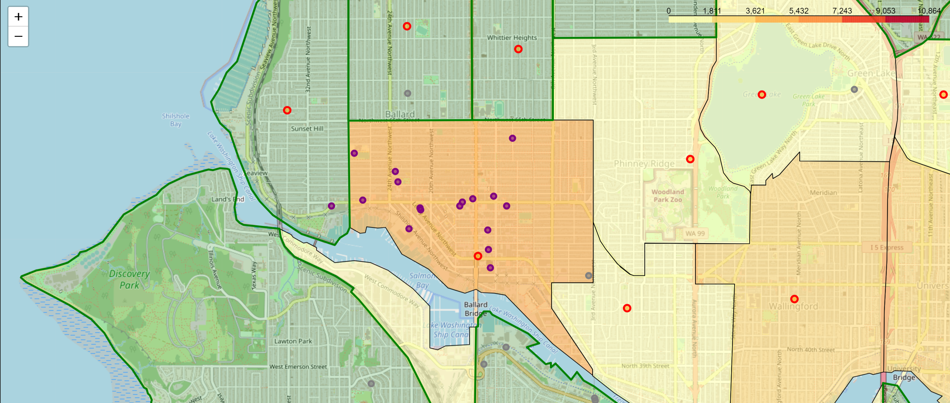

For neighborhood gyms on the other hand, the trick is more to find a location relatively bereft of competing venues. There are a number of such locations in both the North and South of Seattle. Simply looking at Admiral and West Seattle—both growth districts according to the city government, neither seems to have a gym between them, and there are few gyms in the neighboring districts. There are similar opportunities in other sections of Seattle outside of the downtown area.

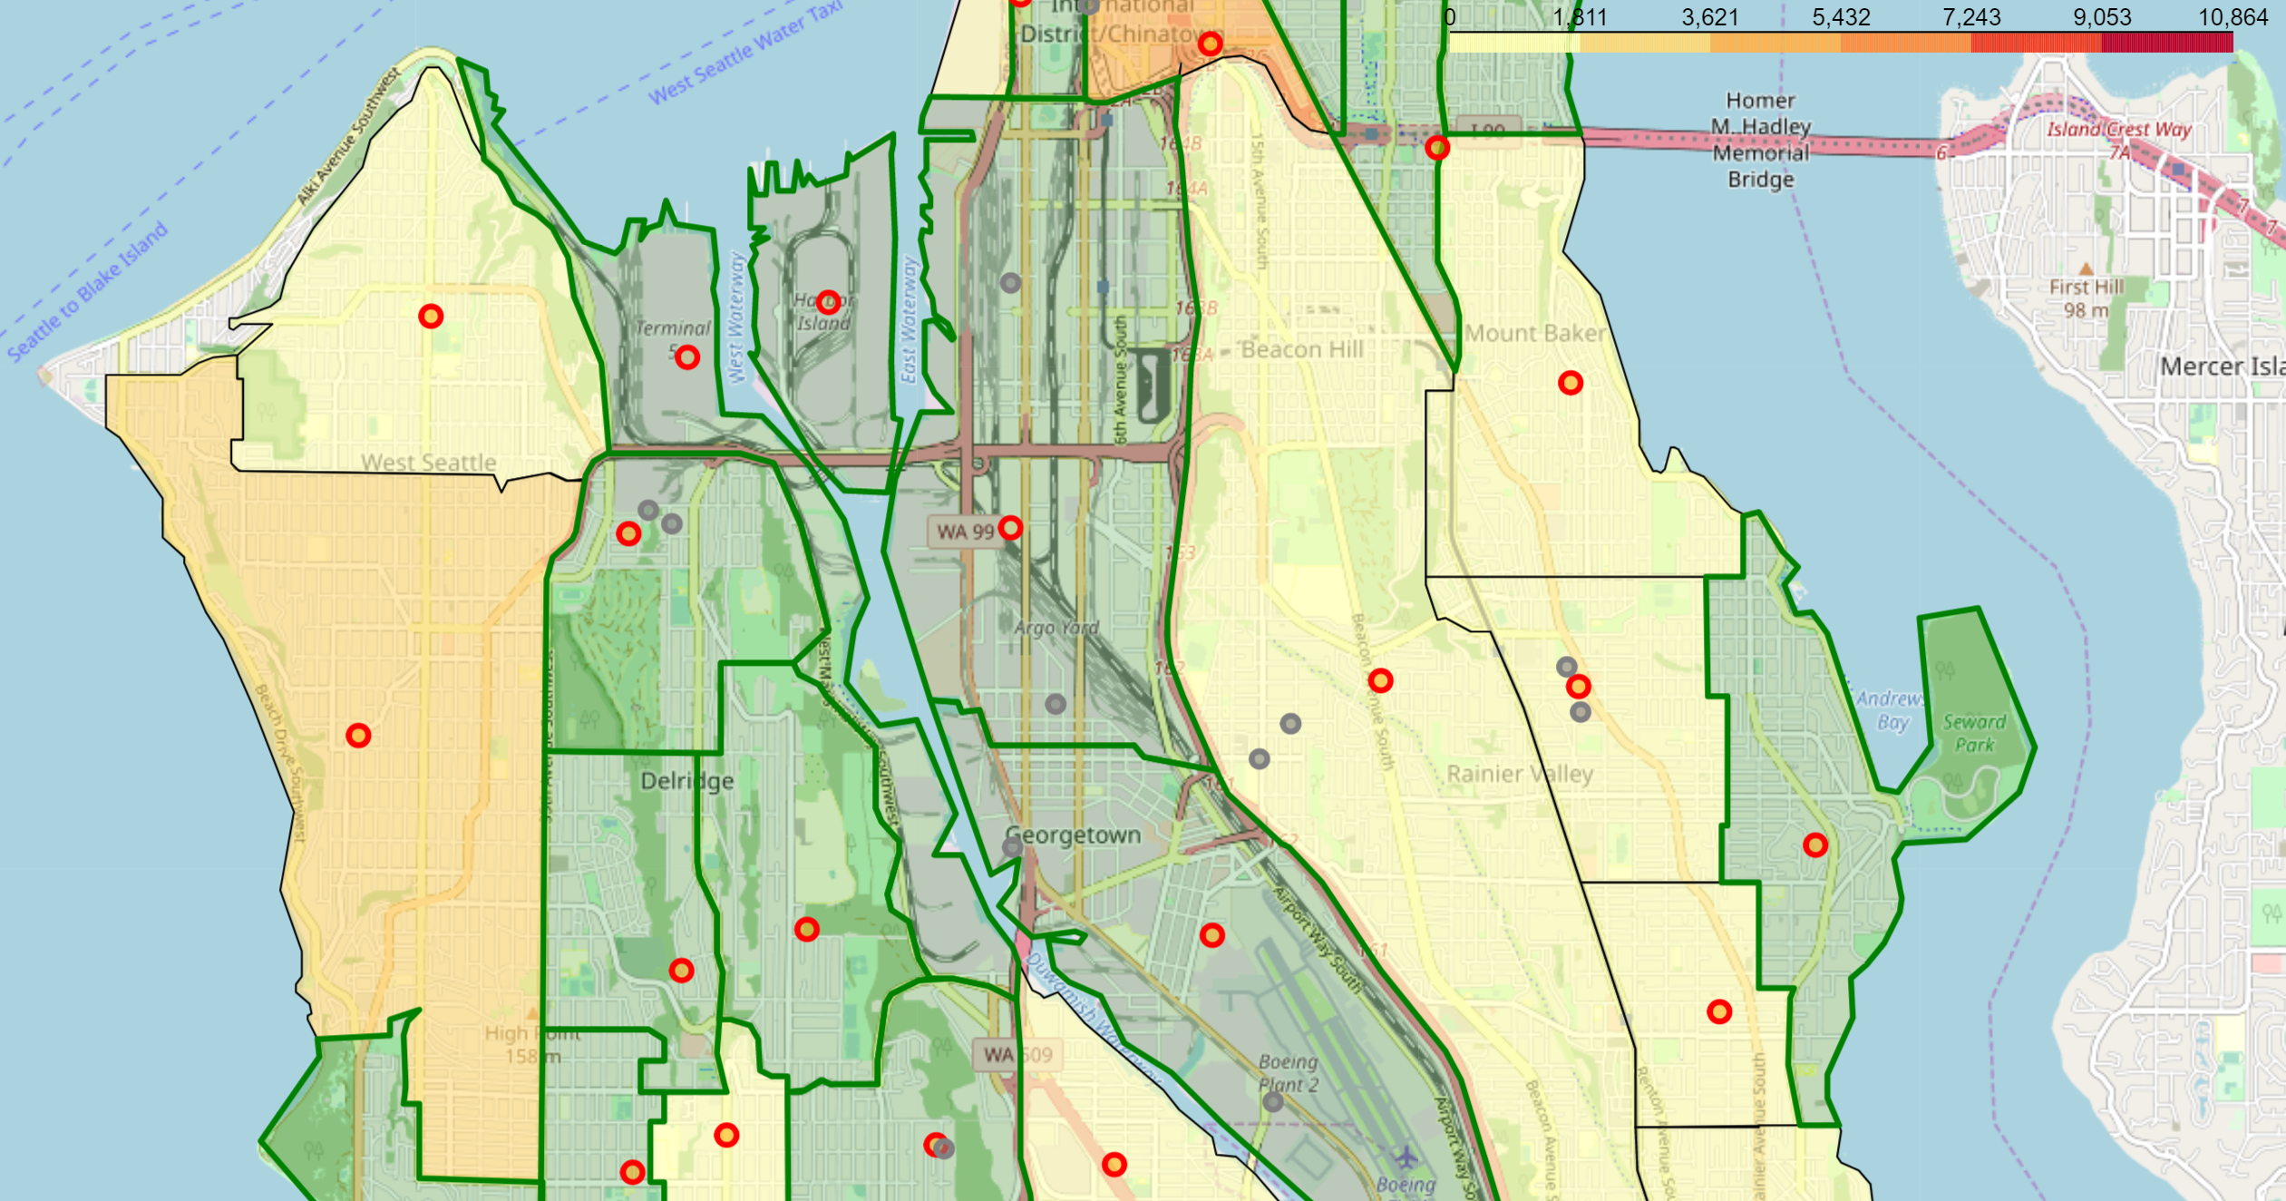

# Conclusion

Seattle’s strong economy and rapid population growth make it an ideal location to attempt to open a gym over the next decade. The relative scarcity of gyms outside of Seattle’s urban core mean that there are excellent opportunities to establish a new neighborhood gym, while strong growth in the downtown region create opportunities for those adopting a downtown strategy as well.